Annex #1
№ | Item | Brand | Model | Current Location | Reserve Price (MDL) | Picture
1 | (No. 1) Frigider cu compartiment congelator / Fridge with freezer compartment | Arctic | AD54240M30W | EXW/ Chisinau, Kogalnicanu 12 | 3100 | 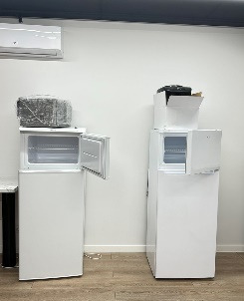
2 | (No. 2) Frigider / Fridge | Arctic | ATL905WN | EXW/ Chisinau, Kogalnicanu 12 | 2500 | 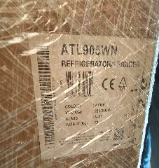
3 | (No. 3) Frigider cu compartiment congelator / Fridge with freezer compartment | Snaige | FR24SM-S200F | EXW/ Chisinau, Kogalnicanu 12 | 4200 | 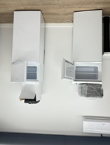
4 | (No. 4) Frigider cu compartiment congelator / Fridge with freezer compartment | Samsung | RB38T600FWW | EXW/ Chisinau, Kogalnicanu 12 | 7700 | 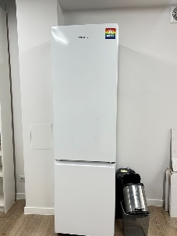
5 | (№ 5)  Climat / Portable air conditioner | Hisense | APH12 | EXW/ Chisinau, Kogalnicanu 12 | 5800 | 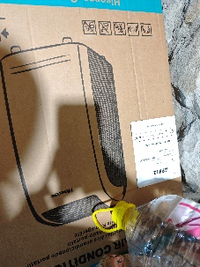
6 | (№ 6) Cintar / Industrial scale (max 2,000 kg)* |  | BXN-2000D1.3-3 | EXW/ Chisinau, Kogalnicanu 12 | 6300 | 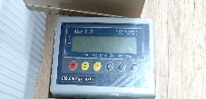
7 | (№ 6) Cintar / Industrial scale (max 2,000 kg)* |  | BXN-2000D1.3-3 | EXW/ Chisinau, Kogalnicanu 12 | 6300 | 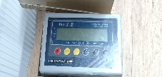
8 | (№ 7) Cintar de tip / Industrial scale (max 1,500kg)* |  | CP P 1500-4-A 1/M | EXW/ Chisinau, Kogalnicanu 12 | 7400 | 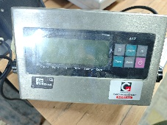
9 | (№ 8)  Cintar platforma electronica de tip / Industrial scale (max 1.500kg)* |  | CP P 1500-4-A1 | EXW/ Chisinau, Kogalnicanu 12 | 7400 | 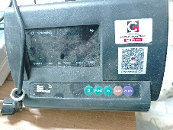
10 | (№ 9) Cintar platforma electronica de tip / Industrial scale (max 300kg)* |  | CP-300-1-A1 | EXW/ Chisinau, Kogalnicanu 12 | 2500 | 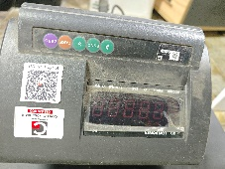
11 | (№ 9) Cintar platforma electronica de tip / Industrial scale (max 300kg)* |  | CP-300-1-A1 | EXW/ Chisinau, Kogalnicanu 12 | 2500 | 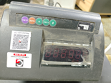
12 | (№ 10) Safeu / Safe (64L) | Valberg | FRS-80(75) T EL | EXW/ Chisinau, Kogalnicanu 12 | 15000 | 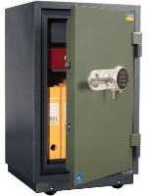
13 | (№ 11) Transpalet manual / Manual pallet jack (max 2,500kg) |  | MC 2500 kg Pu, cod MC2500Pu | EXW/ Chisinau, Kogalnicanu 12 | 3900
14 | (№12) Cuptor cu microunde / Microwave oven | Samsung | MG23F301TAS | EXW/ Chisinau, Kogalnicanu 12 | 1700 | 